Software Design Document

Infrastructure and Inventory Management System

1. Introduction

1.1 Purpose
This software design document outlines the architecture and implementation details for the Infrastructure and Inventory Management System. The system aims to streamline inventory management, room booking, and infrastructure maintenance processes for faculty members and administrators.

1.2 Project Objectives
Develop an efficient inventory management system for consumable and non-consumable items
- Create a user-friendly room booking system with real-time availability
- Implement a damage reporting and repair request workflow
- Provide personalized dashboards for faculty members
- Enable annual inventory audits

1.3 Scope
The system will manage two primary functionalities:
- Inventory Management
- Room Booking System
It will be accessible to faculty members and administrators through web and mobile interfaces.

2. Design Principles

2.1 Fundamental Design Principles
- Problem Partitioning
  - Divide the system into manageable modules
  - Ensure each module can be solved and modified separately
  - Maintain communication between modules
- Abstraction
  - Represent components as black boxes
  - Hide internal implementation details
  - Focus on external behavior and interactions

3. Architectural Design

3.1 System Components
- Inventory Management Module
  - Inventory Dashboard
  - Request Management
  - Personal Faculty Dashboard
  - Damage Reporting
  - Annual Audit System
- Room Booking Module
  - Real-time Room Availability
  - Room Search and Filtering
  - Booking Confirmation
  - Booking Release

3.2 Design Methodology
- Top-Down Design Approach
  - Start with system specifications
  - Define modules implementing specifications
  - Refine modules to the lowest level
  - Ensure clear design visualization at each stage

4. High-Level Design

4.1 Architecture Diagram
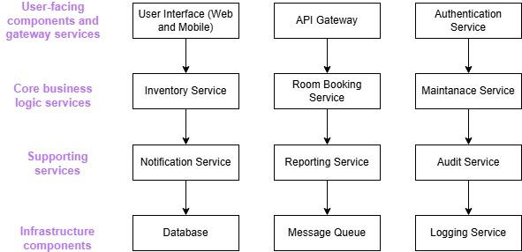

4.2 Component Description
- User Interface: Web and mobile interfaces for faculty and administrators
- API Gateway: Central entry point for all client requests, handling routing and load balancing
- Authentication Service: Manages user authentication and authorization
- Inventory Service: Handles inventory management for consumable and non-consumable items
- Room Booking Service: Manages room availability and booking processes
- Maintenance Service: Handles damage reporting and repair requests
- Notification Service: Sends email notifications and alerts
- Reporting Service: Generates reports and analytics
- Audit Service: Manages annual inventory audits
- Database: Stores all system data
- Message Queue: Facilitates asynchronous communication between services
- Logging Service: Centralized logging for all services

5 Data Design

5.1 Entity-Relationship Diagram
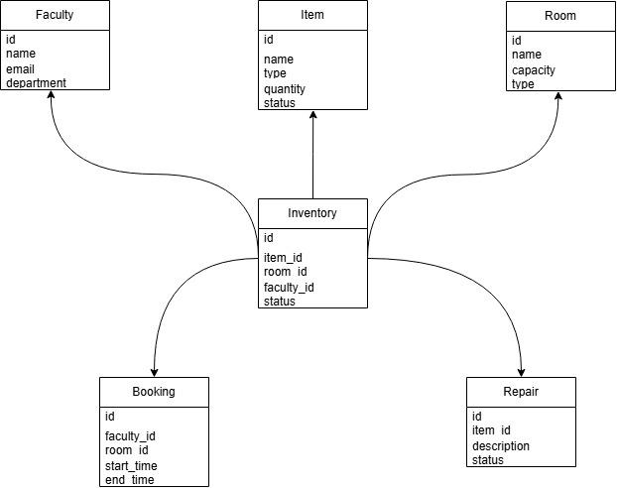

5.2 Data Validation Rules
- Faculty email must be unique and follow a valid email format
- Item quantity must be non-negative
- Room capacity must be positive
- Booking start time must be before end time
- Repair description cannot be empty

6 Interface Design

6.1 API Endpoints
- Inventory Management:
  - GET /api/inventory: Retrieve all inventory items
  - POST /api/inventory: Add a new inventory item
  - PUT /api/inventory/{id}: Update an inventory item
  - DELETE /api/inventory/{id}: Remove an inventory item
- Room Booking:
  - GET /api/rooms: Retrieve all rooms
  - GET /api/rooms/available: Get available rooms
  - POST /api/bookings: Create a new booking
  - DELETE /api/bookings/{id}: Cancel a booking
- Maintenance:
  - POST /api/repairs: Submit a repair request
  - PUT /api/repairs/{id}: Update repair status

6.2 Inventory Management Logic

FUNCTION ProcessInventoryRequest(request)
IF request.type is CONSUMABLE THEN
VALIDATE inventory availability
IF item available THEN
PROCESS request
TRIGGER email notification
ELSE
GENERATE purchase request
ENDIF
ELSE IF request.type is NON_CONSUMABLE THEN
COLLECT detailed specifications
SUBMIT for administrator approval
ENDIF
END FUNCTION

6.3 Room Booking Logic

FUNCTION BookRoom(bookingRequest)
VALIDATE room availability
CHECK room matching criteria
IF room available THEN
CONFIRM booking
SEND email confirmation
UPDATE room schedule
ELSE
NOTIFY user: No rooms available
ENDIF
END FUNCTION

7 Component Design

7.1 Inventory Service
The Inventory Service will handle all inventory-related operations, including:
- Managing consumable and non-consumable items
- Processing inventory requests
- Updating inventory status
- Generating inventory reports

7.2 Room Booking Service
The Room Booking Service will manage room availability and bookings:
- Displaying real-time room availability
- Processing room booking requests
- Releasing bookings automatically or manually
- Generating booking reports

8 Module Structure
- Input Subsystems
  - User Authentication
  - Request Input Processing
  - Room Booking Input Handling
- Transform Subsystems
  - Inventory Request Processing
  - Room Availability Calculation
  - Booking Confirmation Logic
- Output Subsystems
  - Notification Generation
  - Dashboard Rendering
  - Status Update Reporting

9 User Interface Design

9.1 Faculty Dashboard
The faculty dashboard will include the following sections:
- Inventory Request Form
- Personal Inventory List
- Room Booking Calendar
- Damage Reporting Form

9.2 Administrator Dashboard
The administrator dashboard will include:
- Inventory Overview
- Room Booking Management
- Repair Request Queue
- Audit Planning and Reporting

10 Design Metrics

10.1 Complexity Metrics
- Network Metrics: Minimize cross-module dependencies
- Stability Metrics: Reduce interface assumptions between modules
- Information Flow Metrics:
  - Complexity (Dc) = Size * (Inflow * Outflow)^2
  - Identify potential error-prone modules

11 Design Principles Implementation

11.1 Coupling
- Goal: Achieve loose coupling between modules
- Strategies:
  - Minimize interface complexity
  - Use well-defined module entry points
  - Pass information exclusively through parameters

11.2 Cohesion
- Objective: Maximize internal module relationship
- Levels of Cohesion:
  - Functional (Highest)
  - Sequential
  - Communicational
  - Temporal
  - Logical
  - Coincidental (Lowest)

12 Assumptions and Dependencies
- The system assumes a stable internet connection for real-time updates
- The system depends on an email service for sending notifications
- User authentication will be handled by an existing university-wide system

13 Glossary of Terms
- Consumable: Items that are used up and need frequent replenishment
- Non-consumable: Durable items that are not consumed with use
- HSN Code: Harmonized System of Nomenclature code for classifying goods

14 Non-Functional Requirements

14.1 Performance
- The system should respond to inventory queries within 2 seconds
- Room availability and inventory status should be updated in real-time

14.2 Usability
- The user interface should be intuitive and require minimal training
- The system should be accessible on both desktop and mobile devices

14.3 Security
- User authentication and authorization mechanisms shall be implemented
- Sensitive data shall be encrypted at rest and in transit

14.4 Scalability
- The system should be able to handle up to 1000 concurrent users
- The database should be able to store and manage up to 1 million inventory items

15 Future Work
- Implement an automated procurement system
- Integrate IoT sensors for real-time asset tracking
- Develop AI-based recommendations for optimal room booking

16 Conclusion
By following this software design document, the development team can create a robust and efficient Infrastructure and Inventory Management System that meets the needs of faculty members and administrators while ensuring scalability and maintainability for future enhancements.

